Frinika
Milestone 4
Team member Student ID
Buthainah Aldosary 6302459
Jagdeep Singh 6449948
Luiz Mauricio Silva 6317006
Mischell Flor 5428483
Seun Odutola 6078109

Author: Buthainah Aldosary (6302459)
Listener/ Observer pattern:
The purpose of the observer pattern is to define a one-to- many dependency between objects so that when one object changes state, all its dependents are notified and updated automatically (Gamma, Helm, Johnson, & Vlissides, 1995). The benefits of using the observer pattern are that it decreases coupling between classes and increases reusability. The following is a class diagram that shows the interacting classes. The classes ControllerView and PianoRoll are the Subject classes and implement a notify method (namely clientNotifySelectionChange() implemented from the PianoRollPanelAdapter abstract class). When this method is fired, it first gets the part selected and then notifies all its listeners who thus call the method selectionChanged() that repaints its Items. The observer pattern is important in Frinika’s GUI implementation to address extendibility of having more views in the future as well as to decouple classes from each other.
Reverse Engineering tools Used:
ModelGoon 4.4.1 was used as a plug in for the Eclipse IDE to draw class and sequence diagrams.
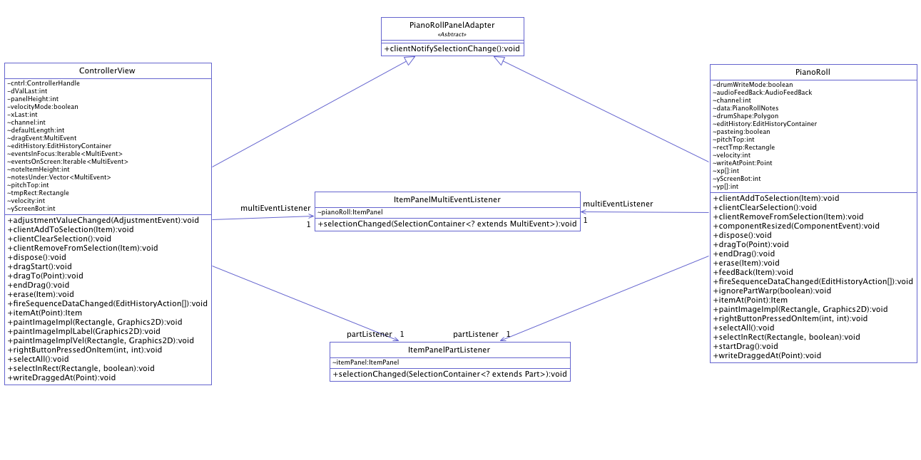
Figure 1: Class Diagram of Subject and Observer Classes.

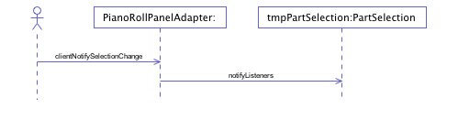
Figure 2: The clientNotifySelectionChange() method Sequence Diagram.
1- Subject Class: ControllerView
public class ControllerView extends PianoRollPanelAdapter implements AdjustmentListener {
int defaultLength;
int pitchTop = 127;
int noteItemHeight;
int yScreenBot;
……… }
2- Subject Class: PianoRoll
public class PianoRoll extends PianoRollPanelAdapter {
public static class PianoRollNotes {
private int noteItemHeight;
private Iterable<MultiEvent> notesOnScreen;
private Iterable<MultiEvent> notesInFocus;
private NoteEvent newNote;
……… }
3- Abstract Adapter Class Extended by both subject classes: PianoRollPanelAdapter
public abstract class PianoRollPanelAdapter extends ItemPanel implements EditHistoryListener,EventFilter
{
public void clientNotifySelectionChange() {
this.project.getPartSelection().notifyListeners(); } }
4- public class ItemPanelMultiEventListener implements SelectionListener<MultiEvent> { ItemPanel pianoRoll;
public void selectionChanged(SelectionContainer<? extends MultiEvent> src) {
pianoRoll.repaintItems(); }
5- public class ItemPanelPartListener implements SelectionListener<Part> {
ItemPanel itemPanel;
public void selectionChanged(SelectionContainer<? extends Part> src) { itemPanel.repaintItems(); } }

Author: <name> (Student ID)
…

Author: <name> (Student ID)
…

Author: <name> (Student ID)
…

Implement a refactoring (7 marks)
Think small! But a rename is not going to be sufficient. You will hand in a patchset. Each patch is a diff of the system showing how the system has changed. The change log will describe why the change was made and its impact on the system. The patches in the patchset should follow a logical order. Each patch must be small, independent, and complete. Err on the side of making many small, independent complete changes. Ideally, you would also provide a test to show that the behaviour has not changed. Each patch should be in an individual file with the name Patchset#-#.patch (ASCII text only). Group them in a zip file. Use git diff to make the patch files.
Patchset 0/2: Refactor class VideoAudio into two classes
1-3 Paragraphs describing how each of the changes (patches in the set) tie together (no diff)

Patchset 1/2: Create new class Audio
1-3 Paragraphs describing why
Diff showing lines changed

Patchset 2/2: Move method audioRecord into Audio class
1-3 Paragraphs describing why
Diff showing lines changed

